Tutorial 2 Exploring with MNIST
This tutorial shows how to define and train a simple Neural-Network with PyTorch and use it via skorch with SciKit-Learn.
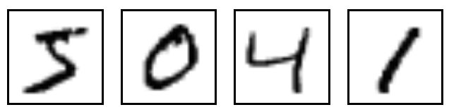

Setup environment
# Import packages
! [ ! -z "$COLAB_GPU" ] && pip install torch scikit-learn==0.20.* skorch
from sklearn.datasets import fetch_openml
from sklearn.model_selection import train_test_split
import numpy as np
import matplotlib.pyplot as plt

# Loading Data
## Using SciKit-Learns fetch_openml to load MNIST data.
mnist = fetch_openml('mnist_784', cache=False)
mnist.data.shape
# Got errors?
## Don't forget what we learlearned from Tutorial 1
## Runtime → Change runtime type → Hardware Accelerator: GPU

The result should show something similar to the picture below.

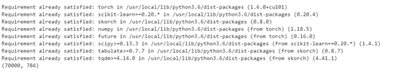

Preprocessing Data
# Preprocessing Data
X = mnist.data.astype('float32')
y = mnist.target.astype('int64')
X /= 255.0
X.min(), X.max()

## Note: data is not normalized.

#%%

X_train, X_test, y_train, y_test = train_test_split(X, y, test_size=0.25, random_state=42)

#%%

assert(X_train.shape[0] + X_test.shape[0] == mnist.data.shape[0])

#%%

X_train.shape, y_train.shape

#%% md

### Print a selection of training images and their labels

#%%

def plot_example(X, y):
"""Plot the first 5 images and their labels in a row."""
for i, (img, y) in enumerate(zip(X[:5].reshape(5, 28, 28), y[:5])):
plt.subplot(151 + i)
plt.imshow(img)
plt.xticks([])
plt.yticks([])
plt.title(y)
#%%
plot_example(X_train, y_train)
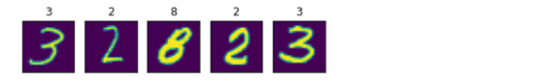

Training with PyTorch Neural Network
# Build Neural Network with PyTorch
## Simple, fully connected neural network with one hidden layer. Input layer has 784 dimensions (28x28), hidden layer has 98 (= 784 / 8) and output layer 10 neurons, representing digits 0 - 9.
import torch
from torch import nn
import torch.nn.functional as F
device = 'cuda' if torch.cuda.is_available() else 'cpu'
mnist_dim = X.shape[1]
hidden_dim = int(mnist_dim/8)
output_dim = len(np.unique(mnist.target))
mnist_dim, hidden_dim, output_dim
# A Neural network in PyTorch's framework.
class ClassifierModule(nn.Module):
def __init__(
self,
input_dim=mnist_dim,
hidden_dim=hidden_dim,
output_dim=output_dim,
dropout=0.5,
):
super(ClassifierModule, self).__init__()
self.dropout = nn.Dropout(dropout)
self.hidden = nn.Linear(input_dim, hidden_dim)
self.output = nn.Linear(hidden_dim, output_dim)

def forward(self, X, **kwargs):
X = F.relu(self.hidden(X))
X = self.dropout(X)
X = F.softmax(self.output(X), dim=-1)
return X
## skorch allows to use PyTorch's networks in the SciKit-Learn setting:
from skorch import NeuralNetClassifier
torch.manual_seed(0)
net = NeuralNetClassifier(
ClassifierModule,
max_epochs=20,
lr=0.1,
device=device,
)
net.fit(X_train, y_train);

The result should show something similar to the picture below.

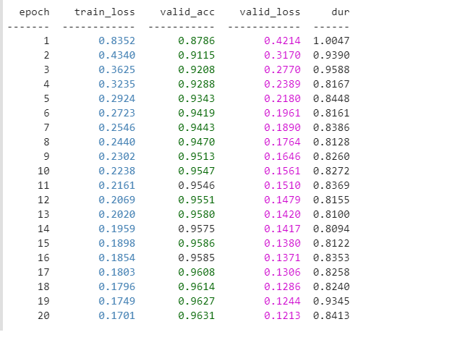

Testing Prediction
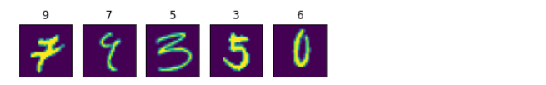
## Prediction

#%%

from sklearn.metrics import accuracy_score

#%%

y_pred = net.predict(X_test)

#%%

accuracy_score(y_test, y_pred)

#%% md

## An accuracy of about 96% for a network with only one hidden layer is not too bad.

## Let's take a look at some predictions that went wrong:

#%%

error_mask = y_pred != y_test

#%%

plot_example(X_test[error_mask], y_pred[error_mask])

Convolutional Network
PyTorch expects a 4 dimensional tensor as input for its 2D convolution layer. The dimensions represent:
* Batch size
* Number of channel
* Height
* Width

# Convolutional Network
XCnn = X.reshape(-1, 1, 28, 28)
XCnn.shape
XCnn_train, XCnn_test, y_train, y_test = train_test_split(XCnn, y, test_size=0.25, random_state=42)
XCnn_train.shape, y_train.shape
class Cnn(nn.Module):
def __init__(self, dropout=0.5):
super(Cnn, self).__init__()
self.conv1 = nn.Conv2d(1, 32, kernel_size=3)
self.conv2 = nn.Conv2d(32, 64, kernel_size=3)
self.conv2_drop = nn.Dropout2d(p=dropout)
self.fc1 = nn.Linear(1600, 100) # 1600 = number channels * width * height
self.fc2 = nn.Linear(100, 10)
self.fc1_drop = nn.Dropout(p=dropout)
def forward(self, x):
x = torch.relu(F.max_pool2d(self.conv1(x), 2))
x = torch.relu(F.max_pool2d(self.conv2_drop(self.conv2(x)), 2))
# flatten over channel, height and width = 1600
x = x.view(-1, x.size(1) * x.size(2) * x.size(3))

x = torch.relu(self.fc1_drop(self.fc1(x)))
x = torch.softmax(self.fc2(x), dim=-1)
return x
torch.manual_seed(0)
cnn = NeuralNetClassifier(
Cnn,
max_epochs=10,
lr=0.002,
optimizer=torch.optim.Adam,
device=device,
)
cnn.fit(XCnn_train, y_train);
y_pred_cnn = cnn.predict(XCnn_test)
accuracy_score(y_test, y_pred_cnn)
## An accuracy of >98% should suffice for this example!
## Let's see how we fare on the examples that went wrong before:
accuracy_score(y_test[error_mask], y_pred_cnn[error_mask])
## Over 70% of the previously misclassified images are now correctly identified.
plot_example(X_test[error_mask], y_pred_cnn[error_mask])
The result should show something similar to the picture below.

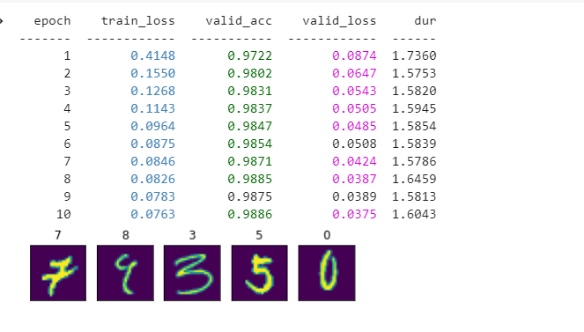

Sample output

Setup

Preprocessing Data

Training with PyTorch Neural Network

Testing Predictions

Convolutional Network

